Rotational Motion Angular Distance: θ How far something rotates.
Angular Displacement: Δθ How far something rotates in a given direction, clockwise (cw) or counterclockwise (ccw). Angles measured in the ccw direction are positive and angles measured in the cw direction are negative. Since the body is rigid, the change in the angle for any point is the same for all points, the, Δθ = θ2 – θ1 is the same for all points.
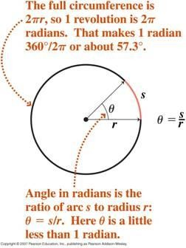

The general rate equation: Rate =
𝜃
𝐶ℎ𝑎𝑛𝑔𝑒 𝑖𝑛 𝐷𝑖𝑠𝑝𝑙𝑎𝑐𝑒𝑚𝑒𝑛𝑡

𝐸𝑙𝑎𝑝𝑠𝑒𝑑 𝑇𝑖𝑚𝑒
can be used to define the average angular

velocity. ω =Δ
𝑡
= angular velocity, where θ = displacement quantity.

Since Δθ is the same for all points on the rigid body, all points of a rigid body have average angular velocity. Note:
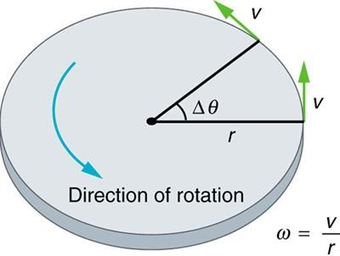

Where v is called the linear or tangential speed because at any given time, the velocity is tangent to the circle as shown in the diagram. Although the velocity is constant in magnitude (speed), it is always changing direction.
The angular velocity ω, must be expressed in radians per unit of time, usually seconds. It is also common to express the rotation rate in revolutions per minute (rpm). Note: 360⁰ = 2𝜋 𝑟𝑎𝑑𝑖𝑎𝑛 = 1 𝑟𝑒𝑣.
- A phonograph turntable has an angular velocity of 45 rpm. What is the angular velocity, ω, in rad/sec.?

- A grindstone rotates 600 revolutions in 5 min. What is the average angular velocity? Note: ω = Δθ/Δt
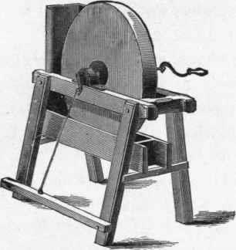

- An automobile with tires of 0.35 meter radius moves at a speed of 18 m/s and travels a distance of
1.6 km. The speed of the tire tread must equal the translational speed of the car, in this case 18.0 m/sec.
- What is the average angular velocity of the tires in rad/s and in rpm? (Note: v = ωr)
- What is the number of revolutions made by the tires? (Note: Δs = Δθ r and 2𝜋 𝑟𝑎𝑑𝑖𝑎𝑛 = 1 𝑟𝑒𝑣.)

- What if someone in the class said that it was possible for a body to have pure translational motion and pure rotational motion at the same time. Would you agree with them? Why?

- How many radians are there in (a) 360⁰ (b) 180⁰ (c) 90⁰
- What are the angular speeds of
- the second hand.
- the minute hand.
- the hour hand of the clock.
- Mr. Astle was given a speeding ticket because a patrolman’s radar showed his car to be exceeding the 55 mi/hr speed limit. At the hearing, three witnesses in the car testified that the speedometer read exactly 55 mi/hr. Yet the judge imposed a fine when she learned that new, oversized tires had recently been installed on the car. Was this a fair ruling? Explain. Would the new tires have any effect on the odometer (mileage meter) reading?

Average Angular Acceleration: If the angular velocity is not constant but changes from an initial value to a final value during a time interval, the rotating body undergoes an angular acceleration (ᾱ). The average angular acceleration is defined as the change in the angular velocity divided by the elapsed

time, or where : ᾱ =
(𝜔−𝜔) (𝑡−𝑡)
𝛥𝜔
=
𝛥𝑡
Note: ωf = ωi + ᾱ t where ωf = final angular velocity; Δθ = ωi t + ½ ᾱ t²

- An airplane propeller accelerates from rest at a constant angular acceleration of 420.0 rad/sec² for
0.5 sec. What is it’s final angular velocity in rpm?

- The angular acceleration of a grindstone is 2.5 rad/sec². The grindstone starts from rest and attains it’s final velocity after 4.0 sec. The initial angular position is taken as zero.
- Find θf it’s angular displacement
- Find ωf it’s final angular velocity after 4.0 sec.

